Zoning Permit Application
In accordance with Spring Garden Township Zoning Ordinance

Project Site Information
Property Address: |  |  | UPI/Tax Map & Parcel Number:
Is the property in the floodplain? |  | ¡ Yes ¡ No

Property Owner Information
Name:  (Last, First) |  | Tele #:
Full Address:
(house #, street, city, state, zip)
Property Owner’s Email Address:
Property Owner’s signature required even if authorizing Contractor as Agent in completing/submission of permit application:

_____________________________________________ _____________________
Property Owner’s Signature (required) Date
Project Details and Site Data
Description of Work
New Impervious Area
Provide details on a separate plot plan (see last page of application) along with the existing structures on the lot (including square footage of structures); show the distance the structures and proposed structure is from property line; provide framing and elevations if necessary.
IMPERVIOUS SURFACE/AREA: A surface that prevents the infiltration of water into the ground. Impervious surfaces and areas shall include, but not be limited to, roofs, additions, patios, garages, storage sheds and similar structures, sidewalks, and pools. However, any surface or area designed, constructed, and maintained to permit infiltration as specified herein shall be considered pervious, not impervious. For the purposes of this chapter, a surface or area shall not be considered impervious if such surface or area does not diminish the capacity for infiltration of stormwater for storms up to, and including, a two-year, twenty-four-hour storm event. (Please complete a Stormwater Management Application).

Lot Size in Acres/sq. ft.:
Building/Addition Sq. Ft.: |  |  | Paving/Concrete Sq. Ft.:
General Information (Must be completed)
Estimated Construction Cost: |  |  | Height of Proposed (fence/pool):
Estimated Start Date: |  |  | Estimated Completion Date:

Certification
I hereby certify that I am the owner of record of the named property, or that the proposed work is authorized by the owner of record and that I have been authorized by the owner to make applications as his authorized agent and I understand and assume responsibility for the establishment of official property lines for required setbacks prior to the start of construction and agree to conform to all applicable laws of this jurisdiction. I further certify that this information is true and correct to the best of my knowledge.
Applicant’s Signature: |  | Date:
Applicant’s Address: |  | Tele #:
Applicant’s Email:
Contractor Information
Name of Contractor: |  |  | Tele #:
Person in charge of work: |  |  | Tele #:
Email address: |  |  | PA HIC Reg. #:
Contractor address
(house #, street, city, state, zip)
Workers’ Compensation Insurance Certificate: |  | ¡ Attached ¡ On File ¡ Waiver

Instructions for Zoning Permit Application

- No work of any kind, including excavation or demolition, may commence until a permit has first been issued by
Spring Garden Township.
- Before filing the application, all applicable Township Ordinances should be consulted as to permissible uses,
set-back requirements, height and size limitations, parking, signage, fencing requirements, impervious lot coverage, stormwater requirements, building construction specifications, etc.
- The application will be deemed incomplete unless the site plan is provided, and all information requested is fully furnished.
- Before commencing any work under a permit, the applicant is required to check all lot lines, street right-of-way lines, and easements, and to strictly comply with the details set forth in the application. Any error made during construction will be required to be removed and corrected at the cost of the applicant.
  - Commencing work without securing a permit compromises your building construction (it may need to be removed)
  - No construction or placement of buildings, fences, sheds, etc. or planting vegetation (other than lawn grass) in an easement or right-of-way (stormwater, sanitary sewer, etc.)
- The duty is upon the applicant, not upon the Township, to prepare and file the application, and to strictly comply with all Township requirements. The Zoning Officer will provide you with the Zoning Officer’s interpretation of Township codes and ordinances and is not permitted to prepare and file the application or plot plans. You have the right to seek the services of a construction contractor, professional engineer, or attorney regarding your building project or permit application.

SEE SAMPLE SITE PLAN NEXT PAGE
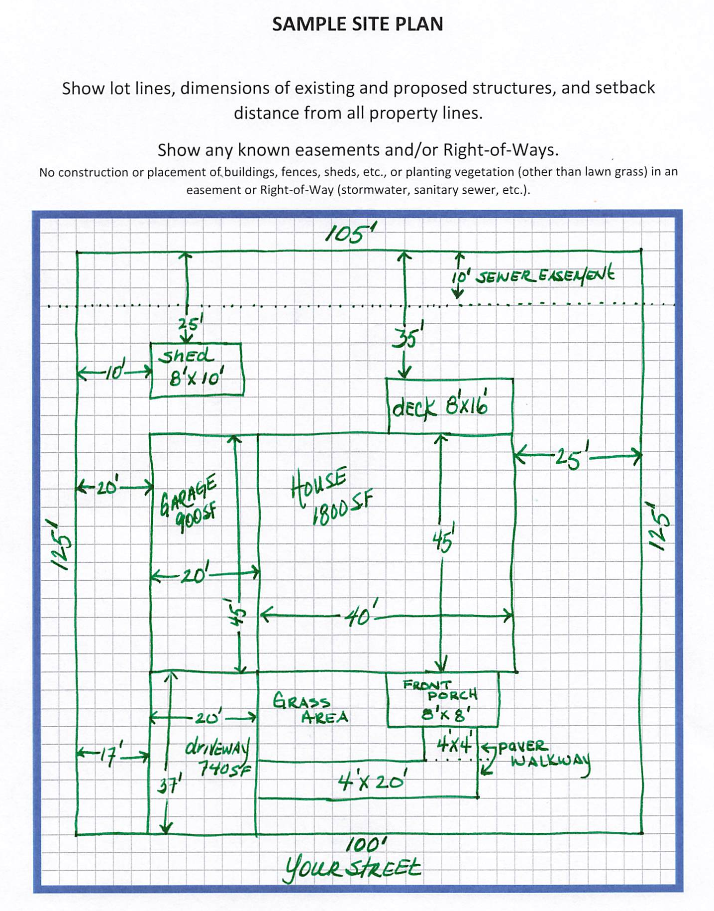

York Office Gettysburg Office
1405 N. Duke St. 240 West Street
PO Box 15627 Gettysburg, PA 17325
York, PA 17405-0156 Phone (717) 334-4000
Phone (717) 845-1584 Fax (717) 337-2565
Fax (717) 854-6376
http://www.yatb.com email: info@yatb.com

TO: Business Enterprises Operating in Spring Garden Township
RE: Local Business Taxes

The York Adams Tax Bureau is Spring Garden Township’s appointed tax collector for Business Privilege and Mercantile Tax (BPMT), Earned Income Tax (EIT) and Local Services Tax (LST).

All individuals, partnerships and corporations conducting or planning to conduct business within Spring Garden Township are subject to the Township’s BPMT. Chapter 284 of the Codified Ordinances of Spring Garden Township defines the levy and collection of the tax, and the requirement to file an annual declaration return on or before May 15. Online filing is available at https://palite.org .

BPMT is a tax on gross receipts. A tax rate of 1.5 mills (0.0015) applies to retail and service businesses, and a tax rate of 1.0 mills (0.0010) is imposed on wholesale business. If a business conducts operations for fifteen days or longer, those receipts are subject to the tax. Manufacturing is exempt from the tax, and certain receipts may be eligible for exclusion under the law. If a business pays the BPMT to another jurisdiction or has out-of-state operations, their gross receipts would be apportioned to determine the amount taxable to Spring Garden Township.

Employers are also required to withhold EIT (a percentage of gross wages depending on where the employee lives) and LST ($52.00 per year) from their employees’ pay and remit it quarterly to YATB. Individuals who are self-employed are also subject to these taxes.

Businesses must register with YATB and obtain a mercantile license prior to conducting operations in Spring Garden Township. Contact our Employer Services Department at 717-845-1584, option 2 to set up an account, or if you have questions. For further information, go to http://www.yatb.com.

